**Home Contents in Transit Marine Insurance Policy**



**Underwritten by DUPI Underwriting Agency**

**INSURANCE CLAIM FORM**

Transworld International Removals Ltd

PO Box 305137, Triton Plaza

Auckland 0757, New Zealand

Ph 64 9 415-0755

insurance@transworld.co.nz

www.transworld.co.nz

**The company does not admit liability by issue of this form**

|  |  |  |  |  |
| --- | --- | --- | --- | --- |
| Claimant |  |  | Transworld Ref. |  |

|  |  |  |  |  |
| --- | --- | --- | --- | --- |
| Address Street |  | Suburb | | |
| City |  | Country | | |
| E-mail |  |  | | |
| Home Ph |  |  | Work Ph |  |
| Mobile |  |  |  |  |

|  |  |
| --- | --- |
| Date goods delivered to you |  |
| Date loss or damage discovered |  |
| Did you sign for any of the goods as damaged or missing | YES / NO |
| Estimate total sound value of all the goods in the shipment before loss or damage | NZ$ |

|  |  |
| --- | --- |
| Full particulars of the circumstances causing the loss or damage. (list details of loss below) |  |
| If there are items missing, provide the names of all notified by you in an attempt to locate the good i.e. removal companies, ship owners, road carriers etc. |  |
| Result of claim against any third parties who have been responsible for the loss, attach all correspondence. |  |

**Written quotations for repair or replacement of the items may be requested from the insurers at a later stage.**

**Please retain damaged goods in case inspection is required.**

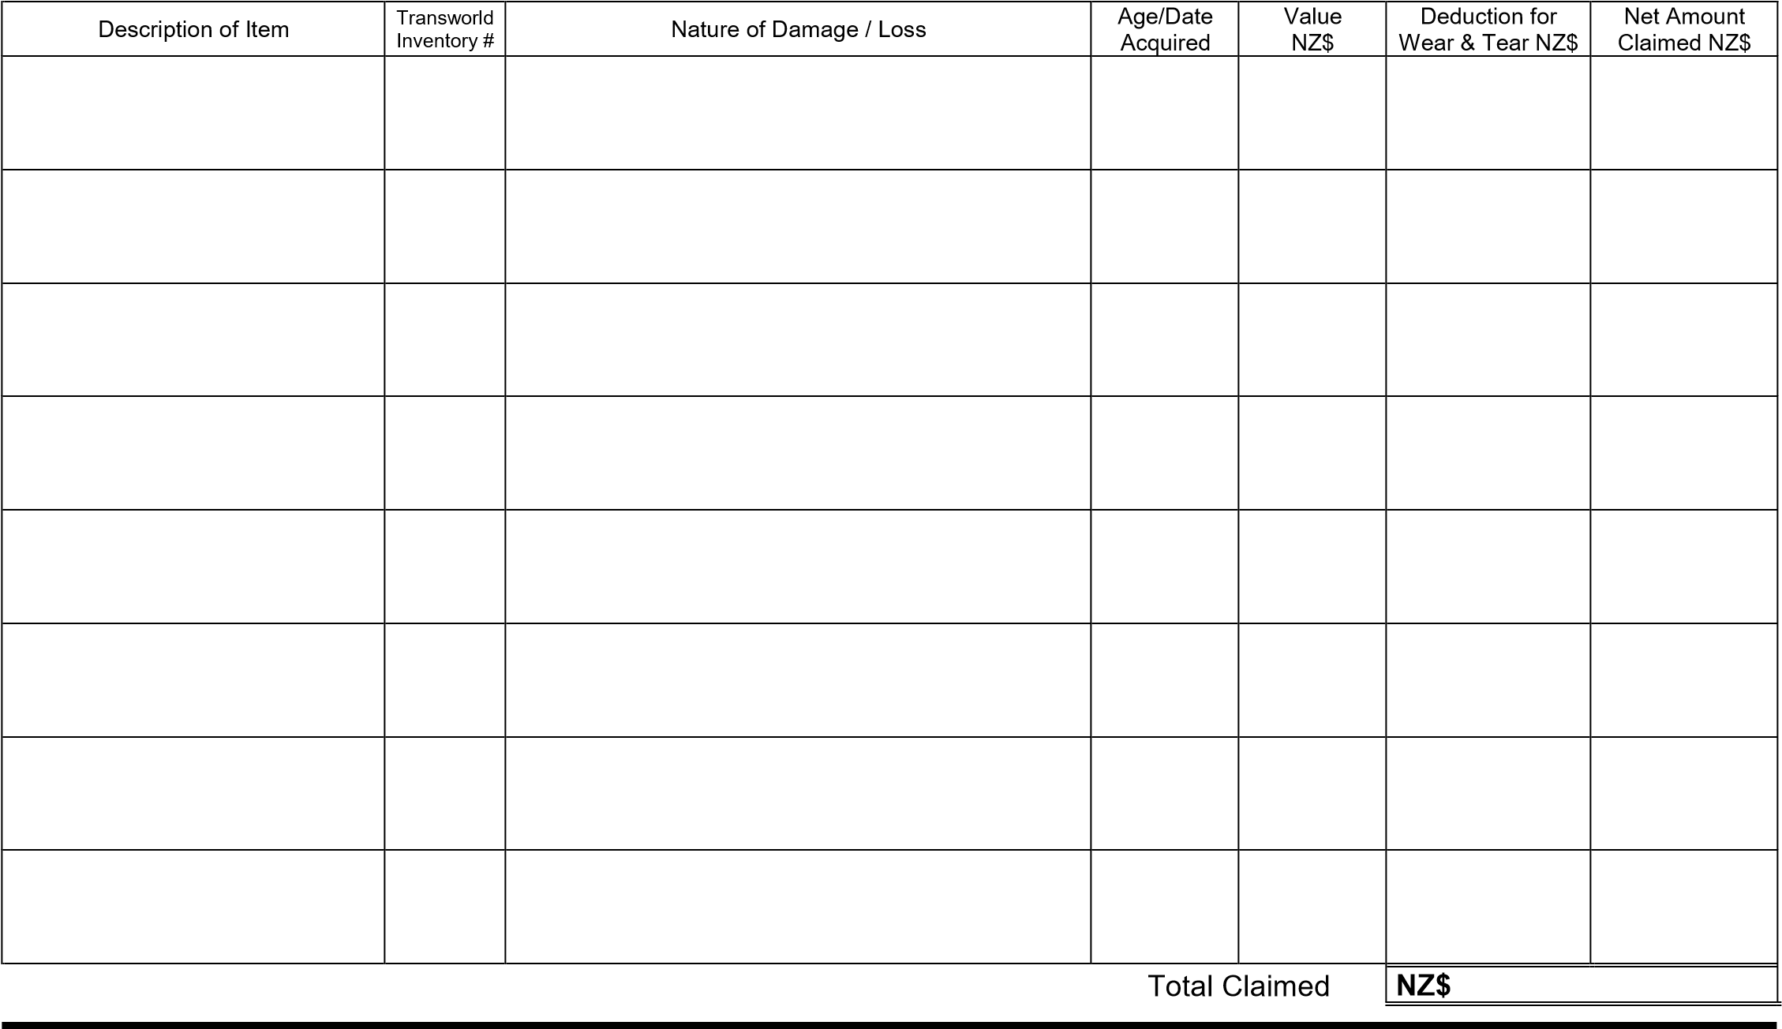

**Pursuant to the Privacy Act 2020, the following is brought to your attention:**

|  |  |  |  |
| --- | --- | --- | --- |
| a)  b)  c) | This claim form collects personal information about you;  The information is collected to evaluate your claim; The intended recipient of the information is Transworld International Removals Ltd and DUPI Underwriting Agencies; | d) e) f) g) | The information is collected and held by Transworld International Removals Ltd and DUPI Underwriting Agencies; The collection of this information is required pursuant to the terms of your insurance policy;  The failure to provide this information may result in your claim being declined; You have rights of access to and correction of this information, subject to the provisions of the Privacy Act 2020 |

**Declaration:**  I/We declare that –

* The information given in this form to be correct.
* I/We agree that should there be any dispute over any payment of this claim, DUPI Underwriting Agencies shall be entitled to submit the dispute to arbitration.
* I/We authorise and request the New Zealand Police to release to DUPI Underwriting Agencies copies of any or all documents held by the New Zealand Police relating to the incident giving rise to this claim. If necessary, this authority should be treated as a formal request pursuant to the Official Information Act 1982.
* I/We authorise the disclosure of personal information held by any other party regarding this claim.
* I/We agree to Transworld International Removals Ltd and DUPI Underwriting Agencies releasing to the other parties personal information regarding this claim.
* I/We authorise the insurer or its authorised agent to give or obtain from any other insurers or other parties any information relating to any insurance held or claim made.

**Note: Failure to provide full and correct information could result in your claim not being accepted by Transworld International Removals Ltd or DUPI Underwriting Agencies**

Signature of Claimant: _______________________________ Print Name: _____________________________________ Date: ______________